Minutes of Meeting

Monday 15th July 2016

**Attendances:**

Libby Dowling  
Phillipa Schliebs

Min Zan

[Gerard Gassol Quilez](https://plus.google.com/109938553995789711538?authuser=1)

https://mail.google.com/mail/u/1/images/cleardot.gif

1. Time and Place

The meeting was hold in level 6 Wills Building, Room 636 11:00am, 15/07/16.

1. Summary of Previous Meeting and Progress

At the beginning, Yue Zhou introduced the technology architecture of the project. Due to the requirements that the development should be swift and the application should be deployed in many different platforms, such as Android phone and Iphone, Html5 + Css3 + JavaScript is adopted as the implement technique. Min Zan introduced the visual and game design of the project. The overall features and style are good, while the first and last game are a bit similar. Hence, some modification should be done to improve this problem. More waste type icons could be added into last game. There is not a specific classification type for paper recycling, because this type is treated as general recycle waste in current project. The energy coin function could be planned in the next stage of project development.

1. Summary of this Meeting

For the name of this application, each game and other description words, all of them will be treated as literature issue. To achieve the final agreement, the involvements of both clients and developers are important. For this reason, firstly, the project team will prepare several options and then discuss with clients again so as to obtain the optimal decision.

For the icon issue, Min Zan will send the list of all required waste images to Libby. The missing pics should be marked out.

For the game design issue, the key points are shown below:

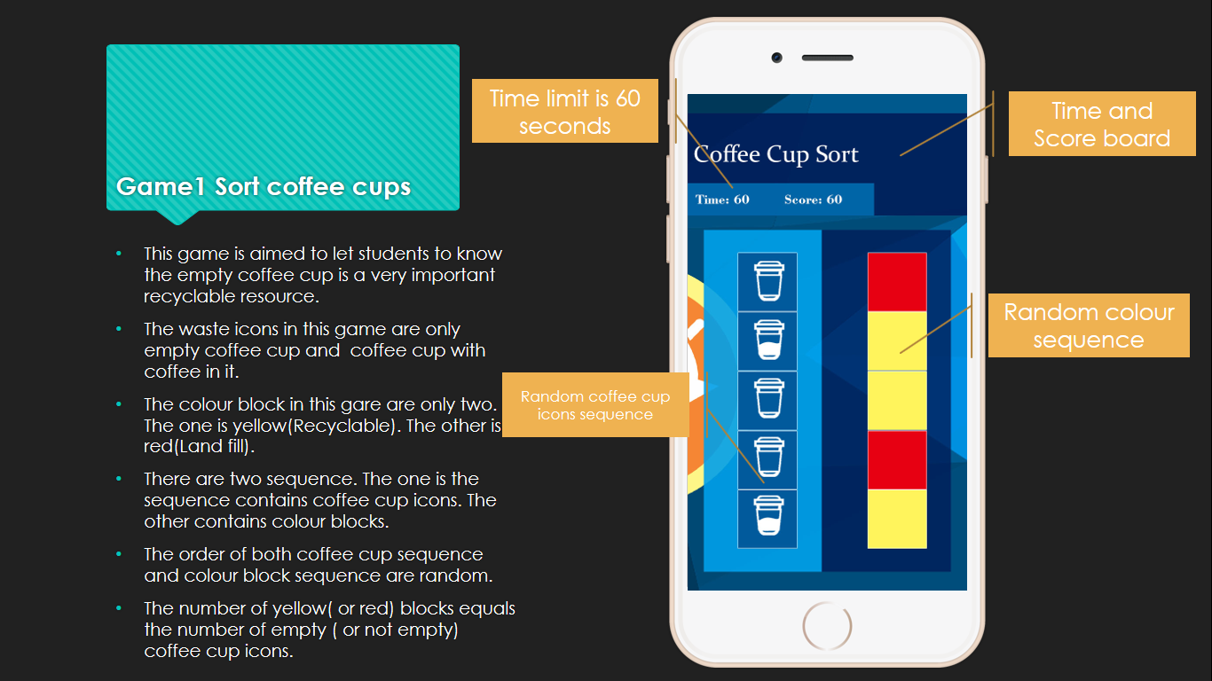

1. Sort coffee cups game.

* The name of coffee cup (or empty coffee cup) should be labelled under each icon to make the meaning of it more clearly.
* The name of recycle type should also be abled on each colour block. The name for red one is not “land fill” but “waste”. This name must be the same in other games.

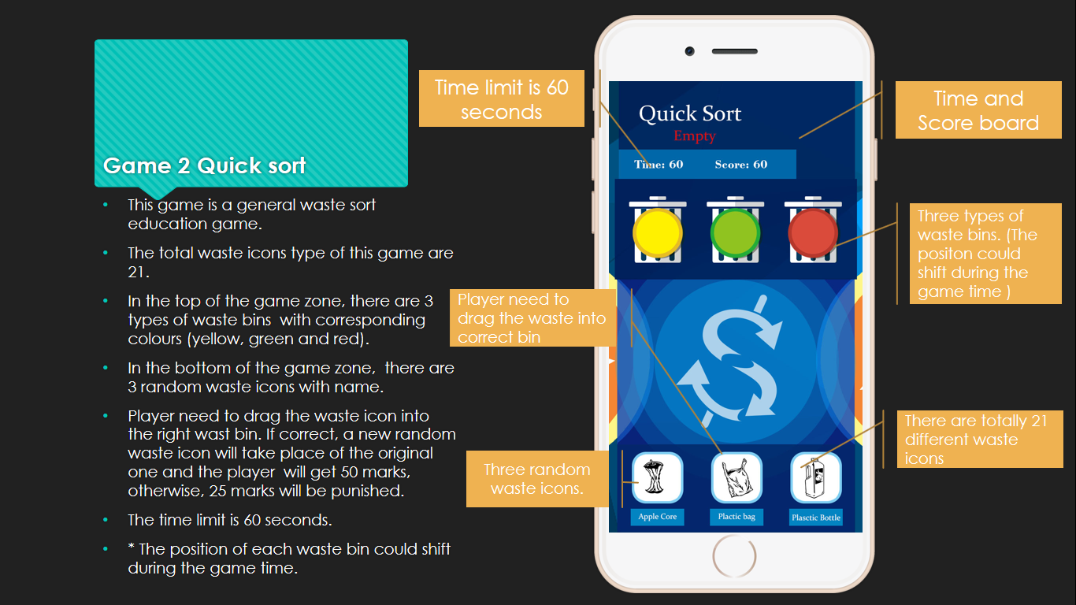

1. General waste sort game1.

* The icons of the waste on the bottom should be changed to larger ones.
* The label of the waste icons should be more clear.
* If time is enough, the game zone could be changed to white style for a try.

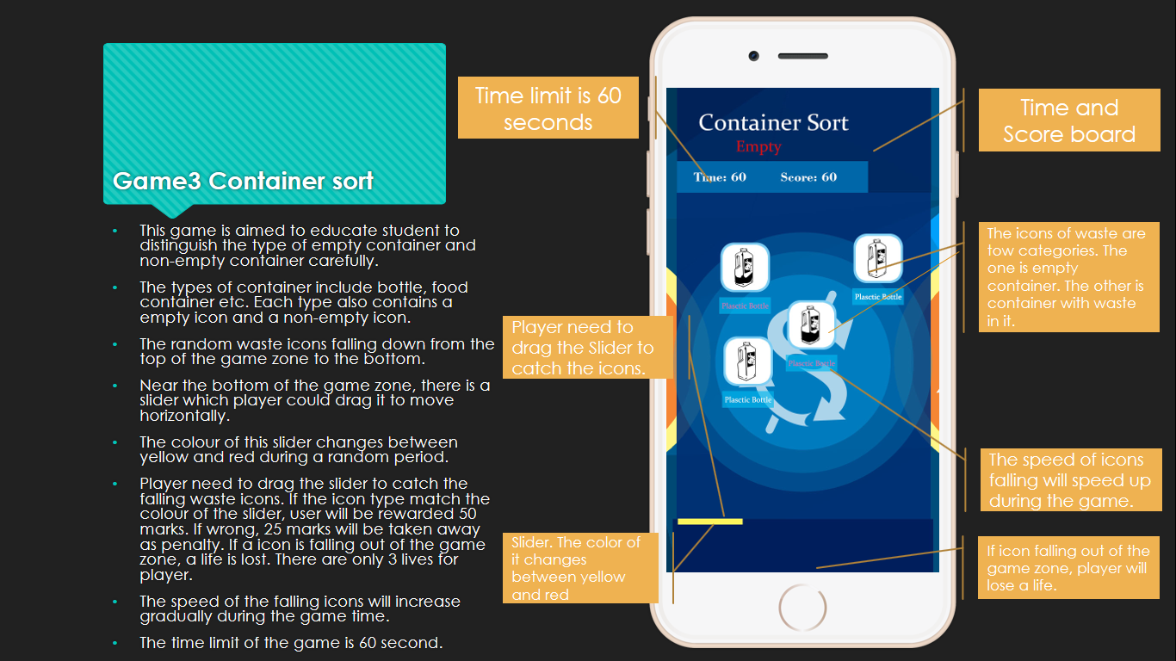

1. Container sort game.

* The label of falling down waste icons should be more clear.
* The slider should be larger. It is better to add a waste bin image under the slider to make the meaning of this bar more clearly.

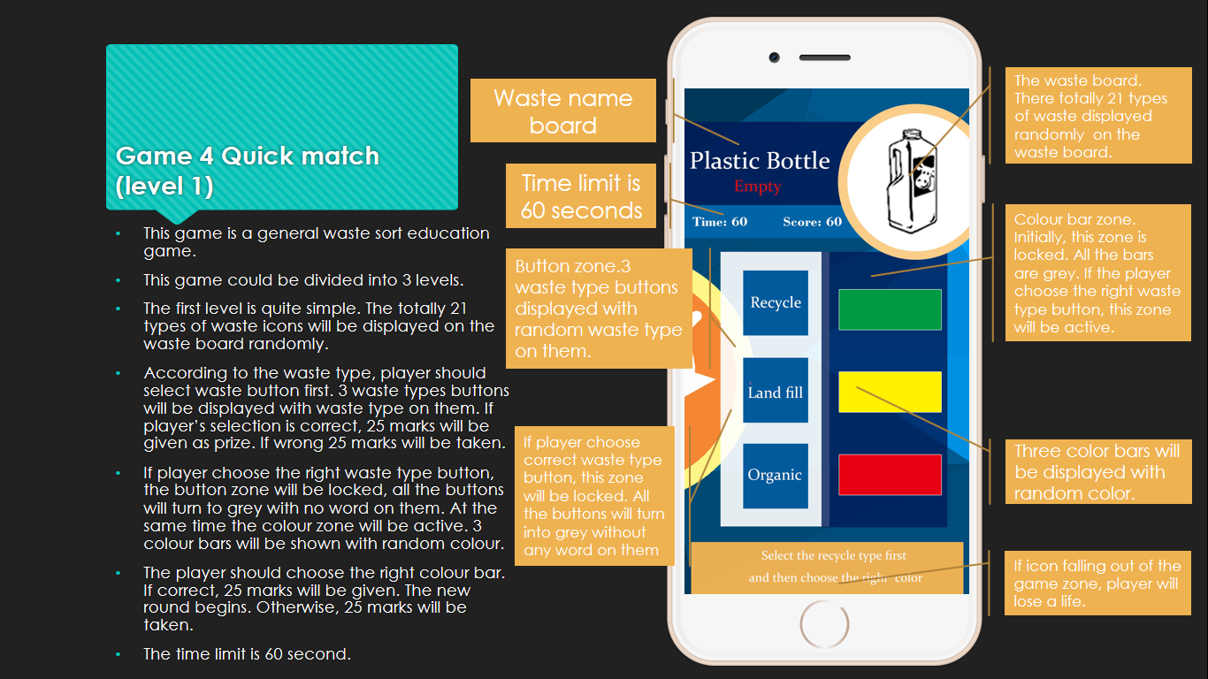

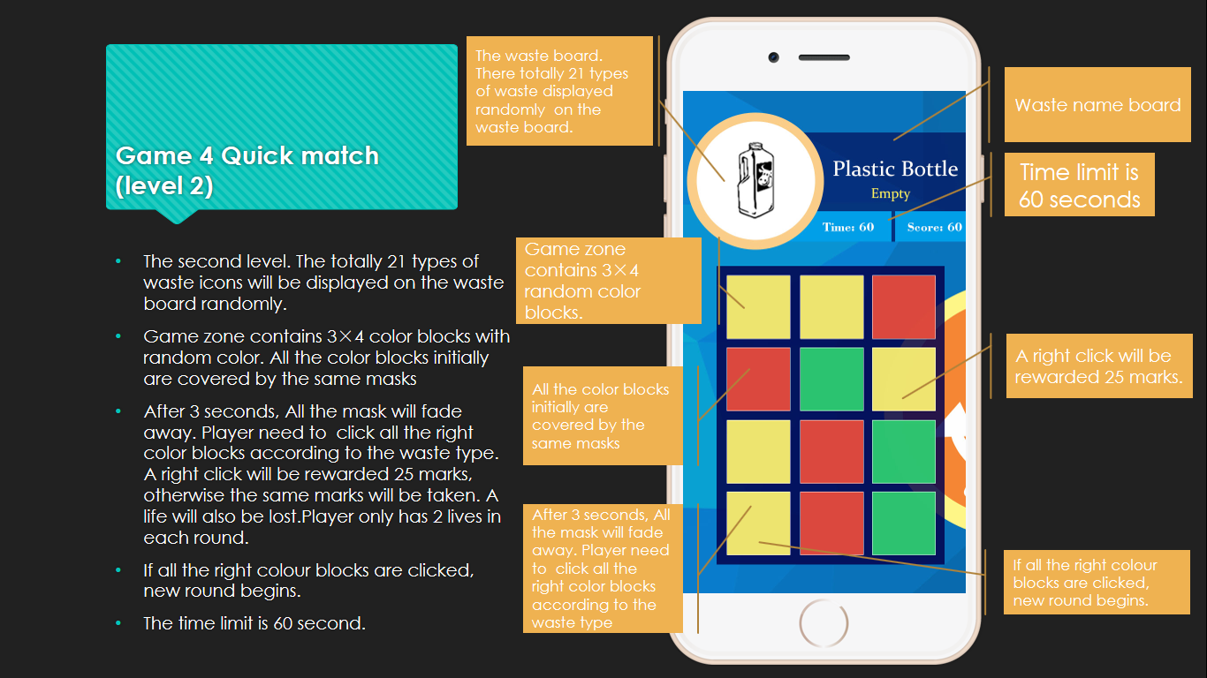

1. General waste sort game2.

It is good to design this game by multi-levels. The design existing 3 levels are fine. It could be better to add another level by such design:

* The waste board display the colour of waste recycle type.
* The colour block will be replaced by random waste icon.
* Player should click all right waste icons according to the colour shown on the waste board.

For the future plan, the draft application will be published on 8th August. There will be 1 week for testing. By the end of 29th August, the gif reward function should be available. After that, there will be 1 week for getting feedback and making data analysis. It is estimated that the design of coin exchange system should be done after 19th September.

Other important opinions:

The coin exchange system would be quite complicated. There are many difficult problems to solve, such as security issues and the calculation of coin value. So the design of the coin system should be started early. The suggested beginning time is the week after next week.

The next meeting will be held at 11:00am next Friday. Min Zan will display the basic game demos during the meeting.